AM000-Asia-China-Warring States-Mirror-4 T- 475–221 BCE

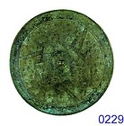

[Warring-States Bronze Mirror 4 Pictured 'Mountain's](http://www.ebay.com/itm/110850819937?ssPageName=STRK:MEWNX:IT&_trksid=p3984.m1439.l2649) (110850819937)

Sale date: 05/11/12

Tracking number: --

Estimated Delivery: 06/12/12 - 06/25/12

$315.00

+ $12.00

shipping